**(25) Ocean Currents**

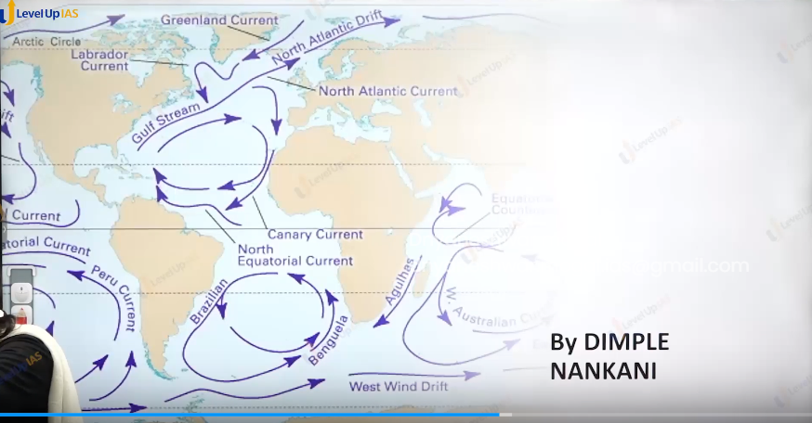

Ocean Currents:

1. Ocean currents refer to the movement of ocean water in a definite direction. They are also called narrow bands of circulate water along the coast.
2. The primary force that generates the ocean currents is wind.
3. Other factors that play an important role are density differences because of salinity and temperature difference.
4. Coastline and ocean bottom topography, ocean bottom reef.
5. Coriolis force

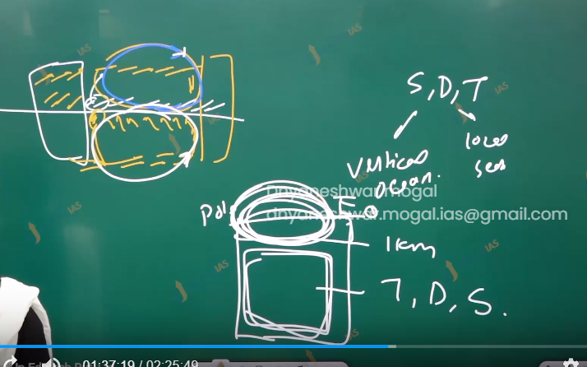

Factor effacing ocean current:

1. Winds and ocean current: trade winds drag the water from east to west. And westerlies drag water west to east.
2. The coastline turns the water to the right in the northern hemisphere. Along with Coriolis force and left in the southern hemisphere.

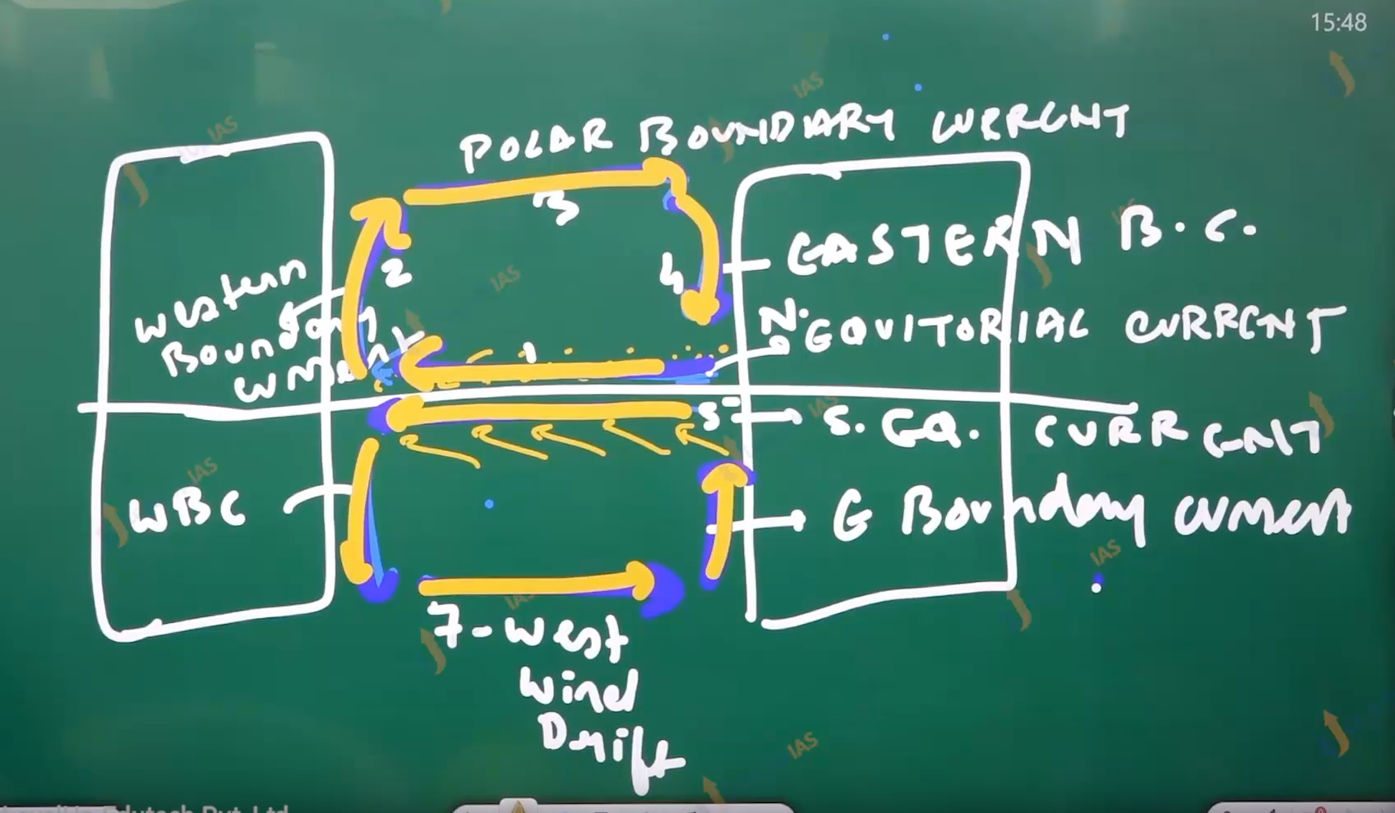

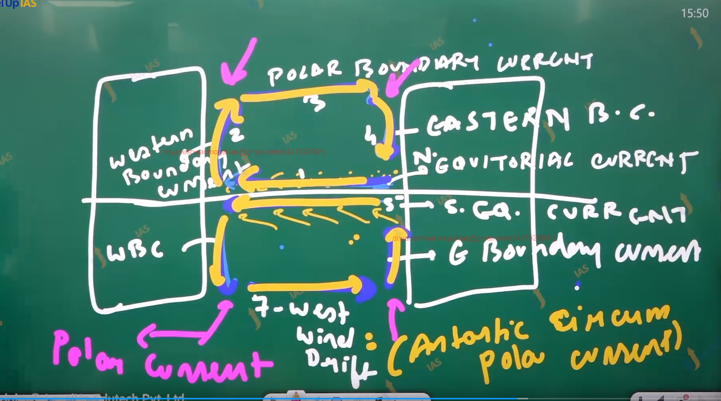

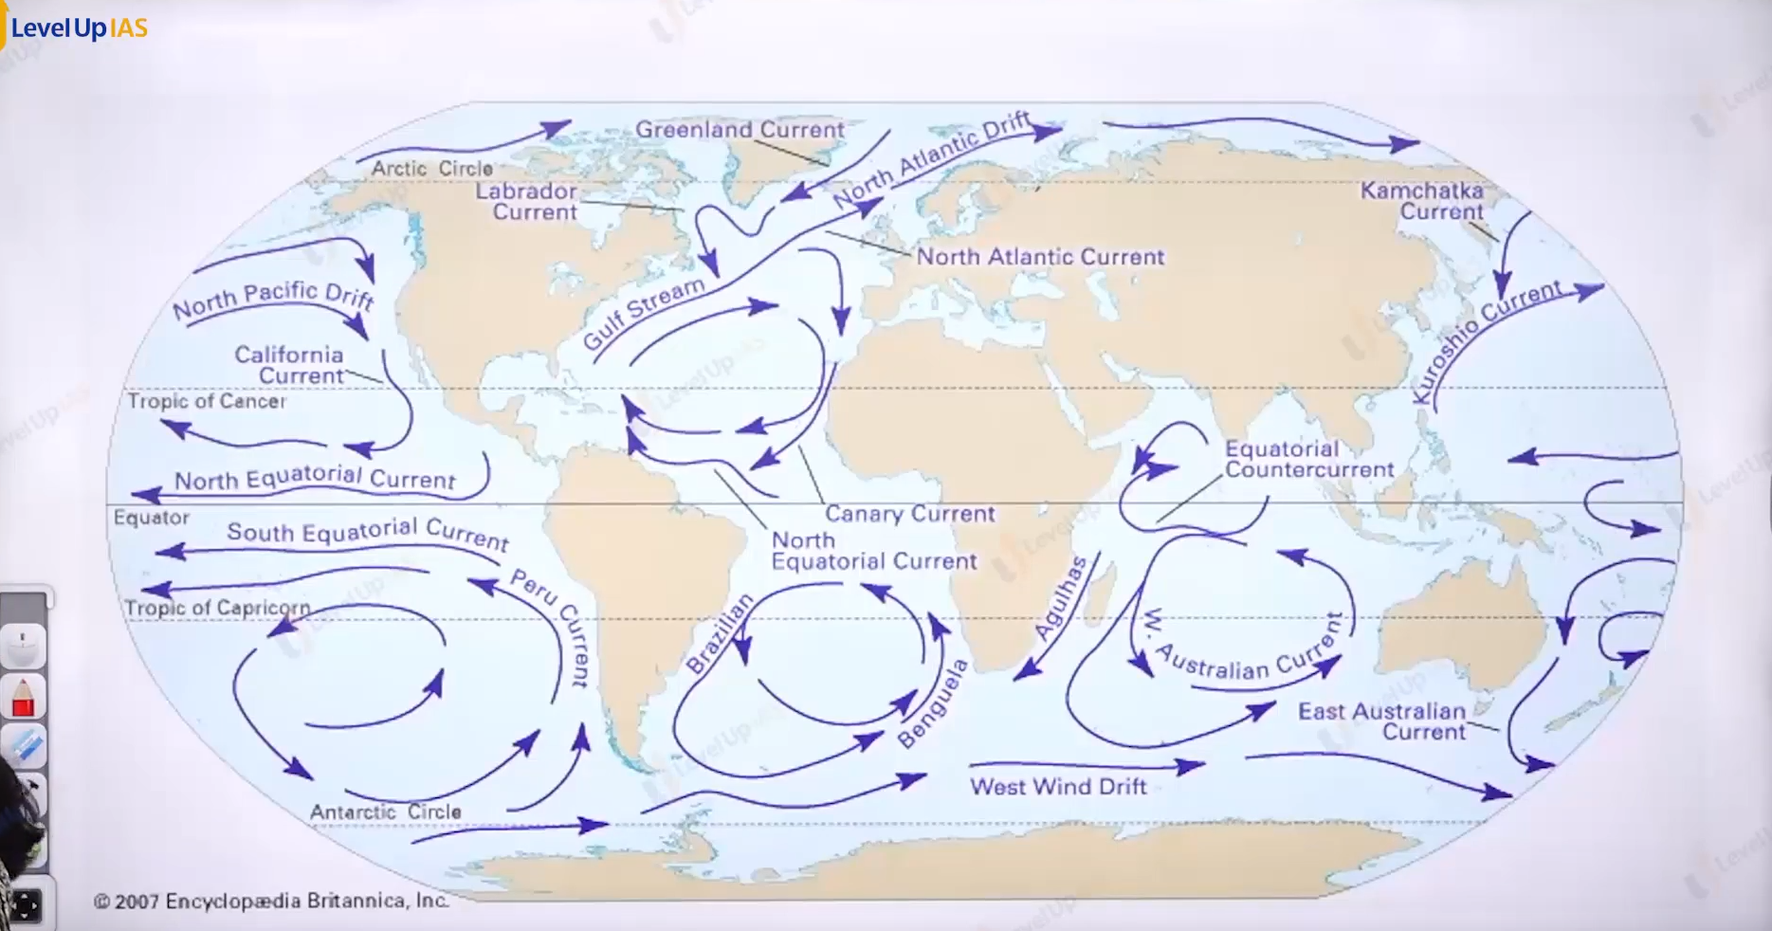

You must learn the how to draw the world map.

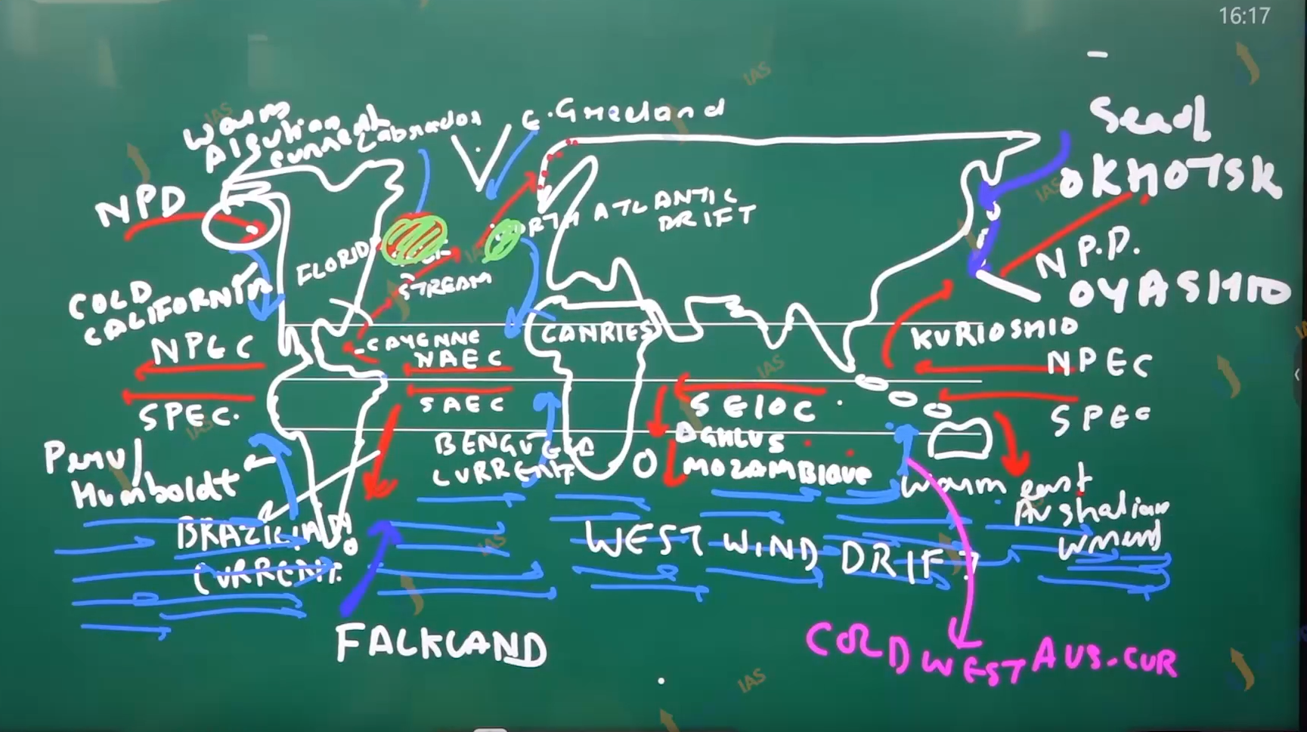

Diagram of ocean current and their name.

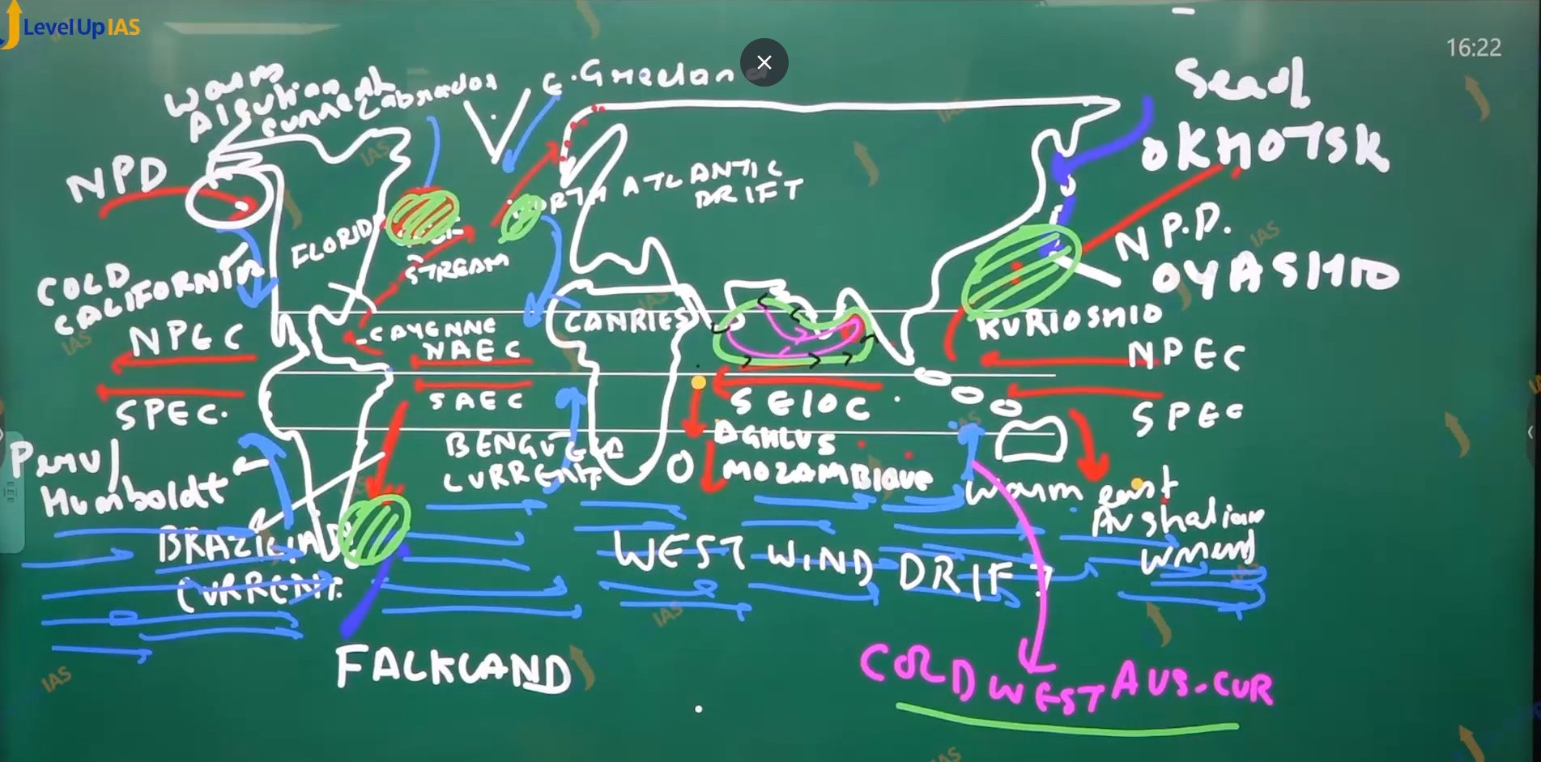

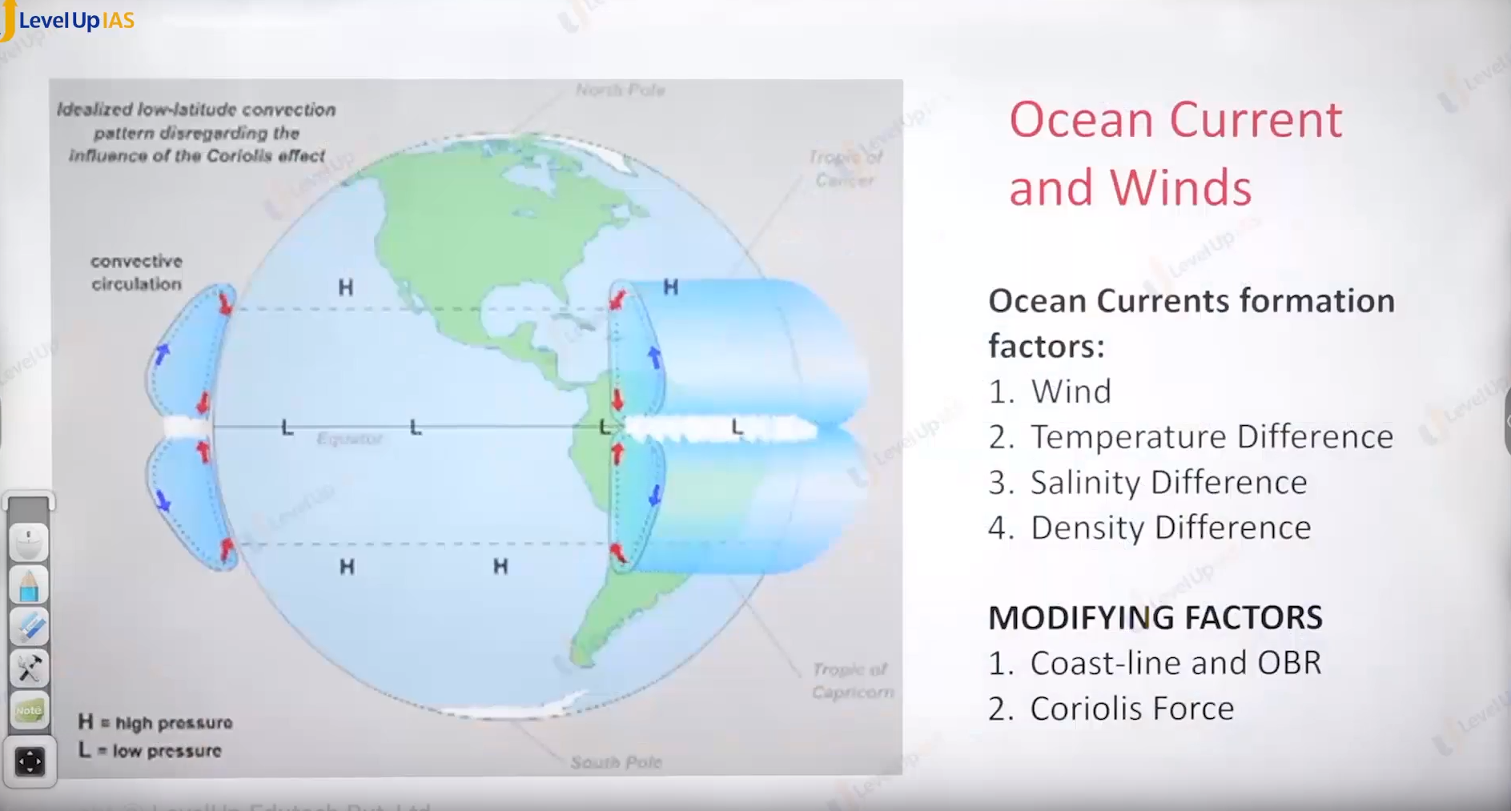

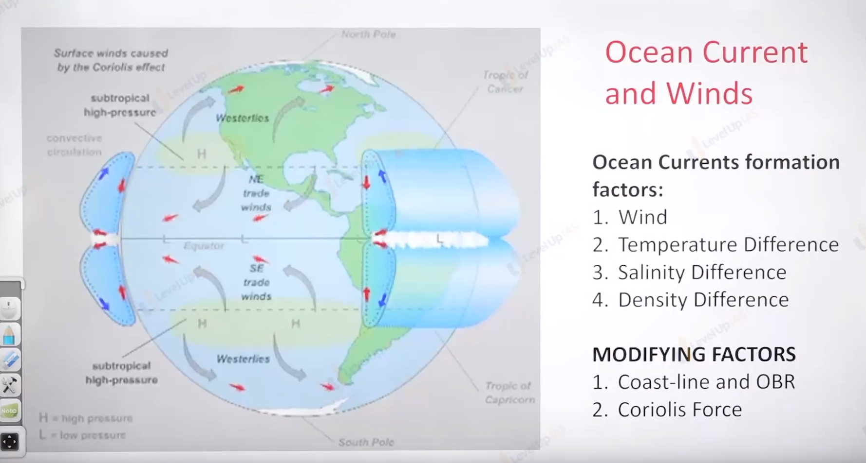

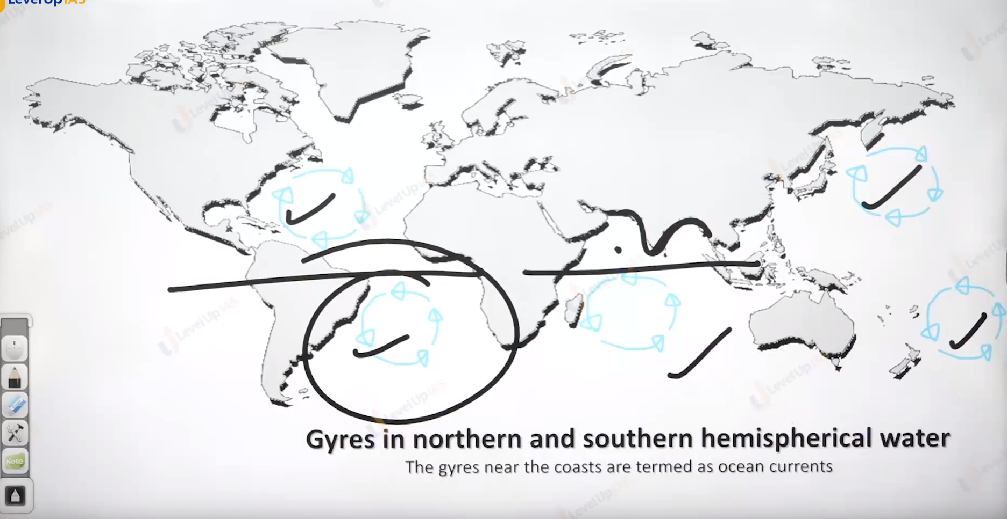

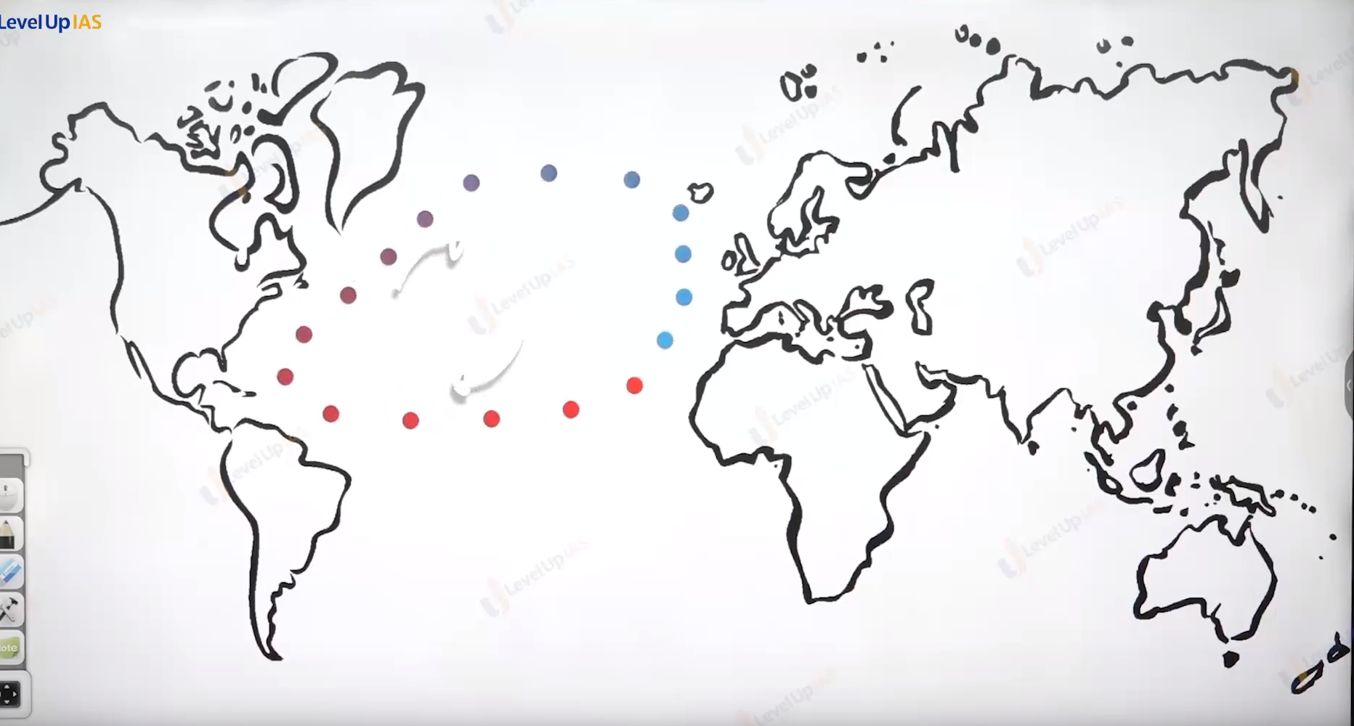



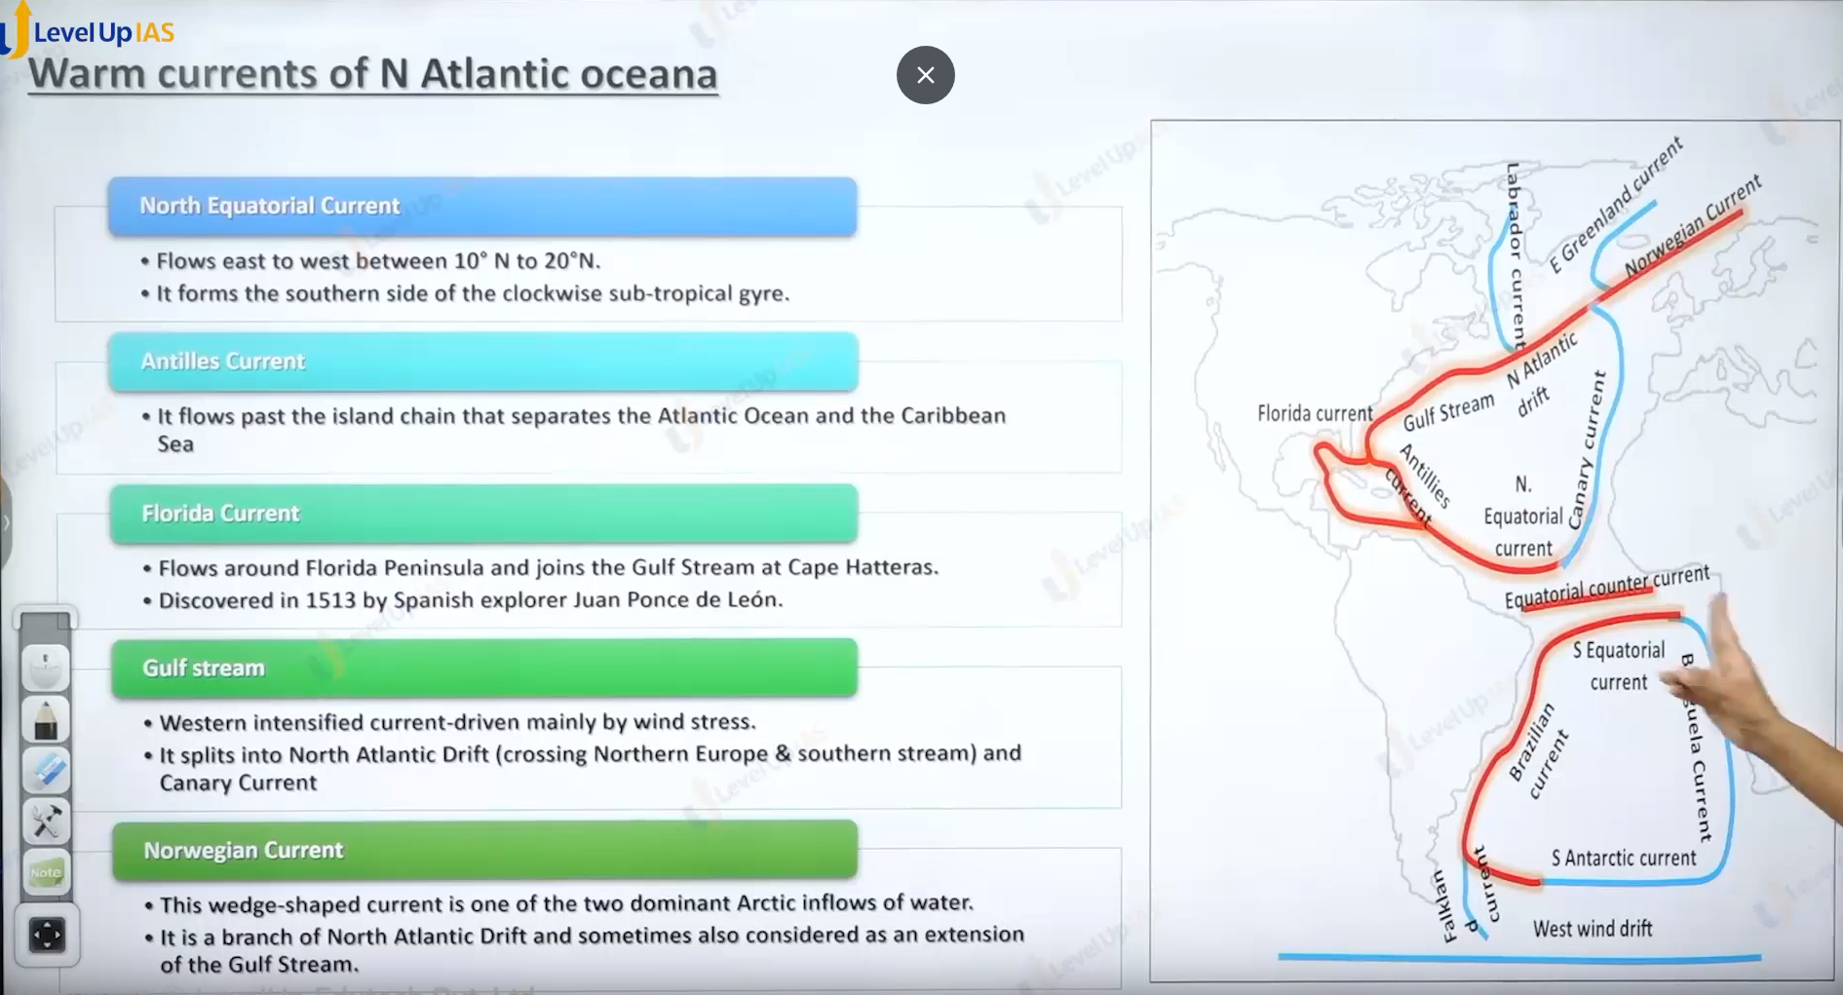

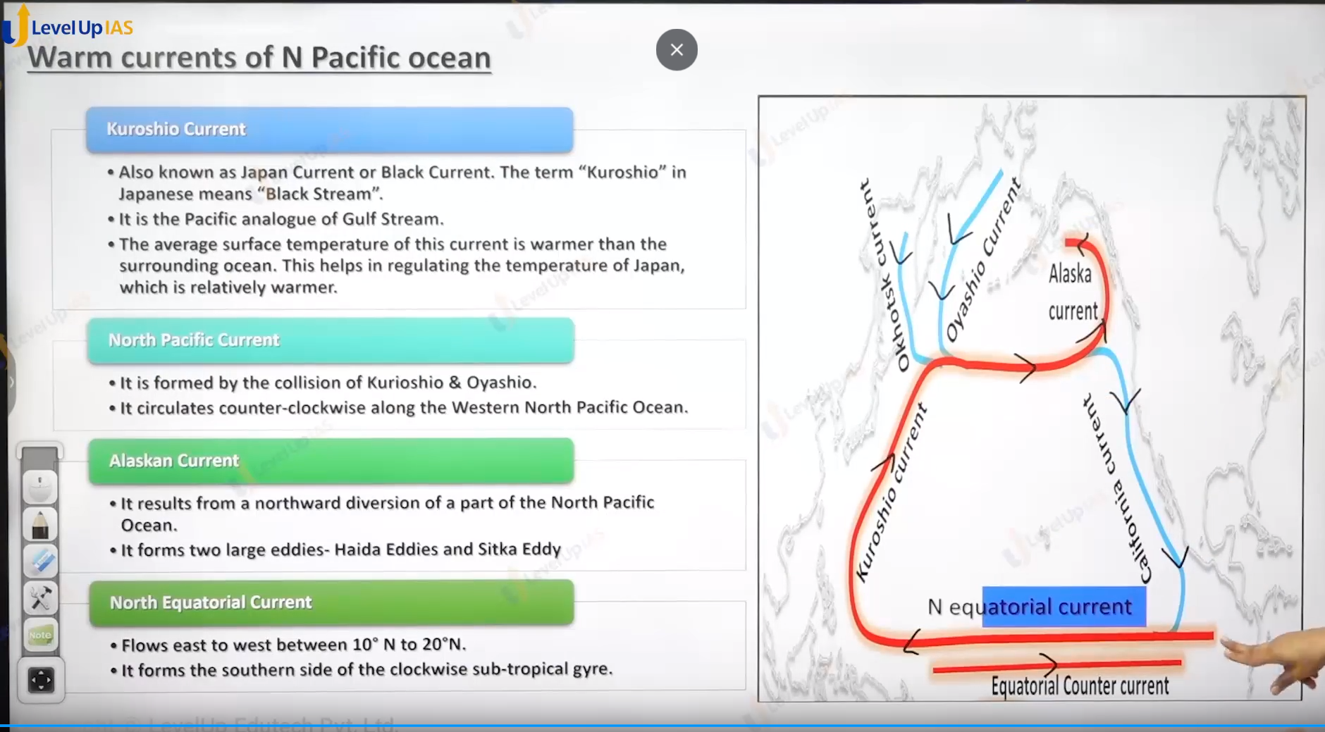

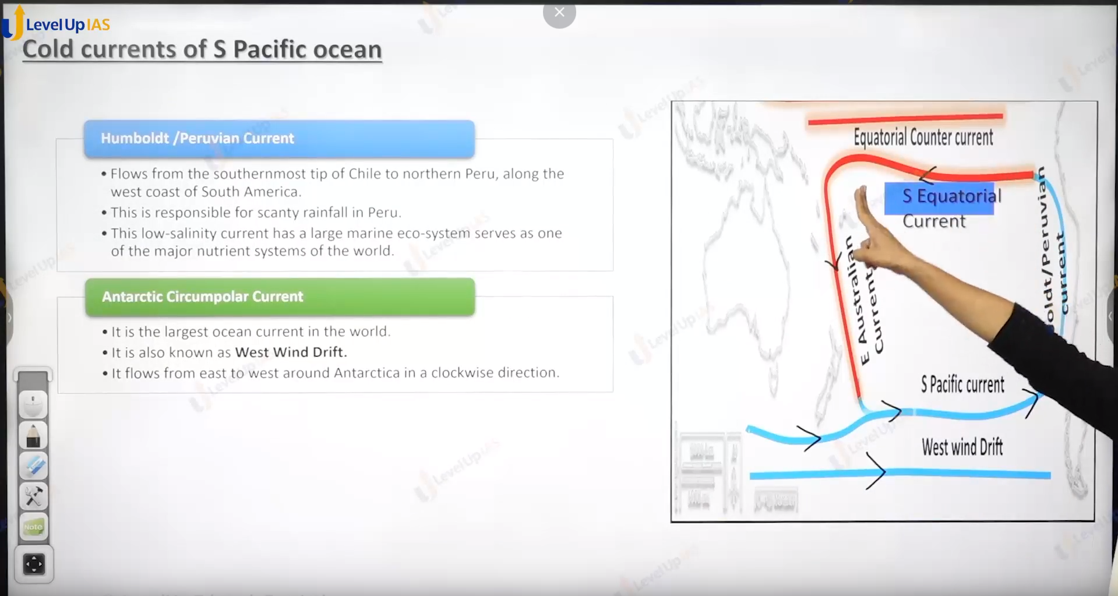

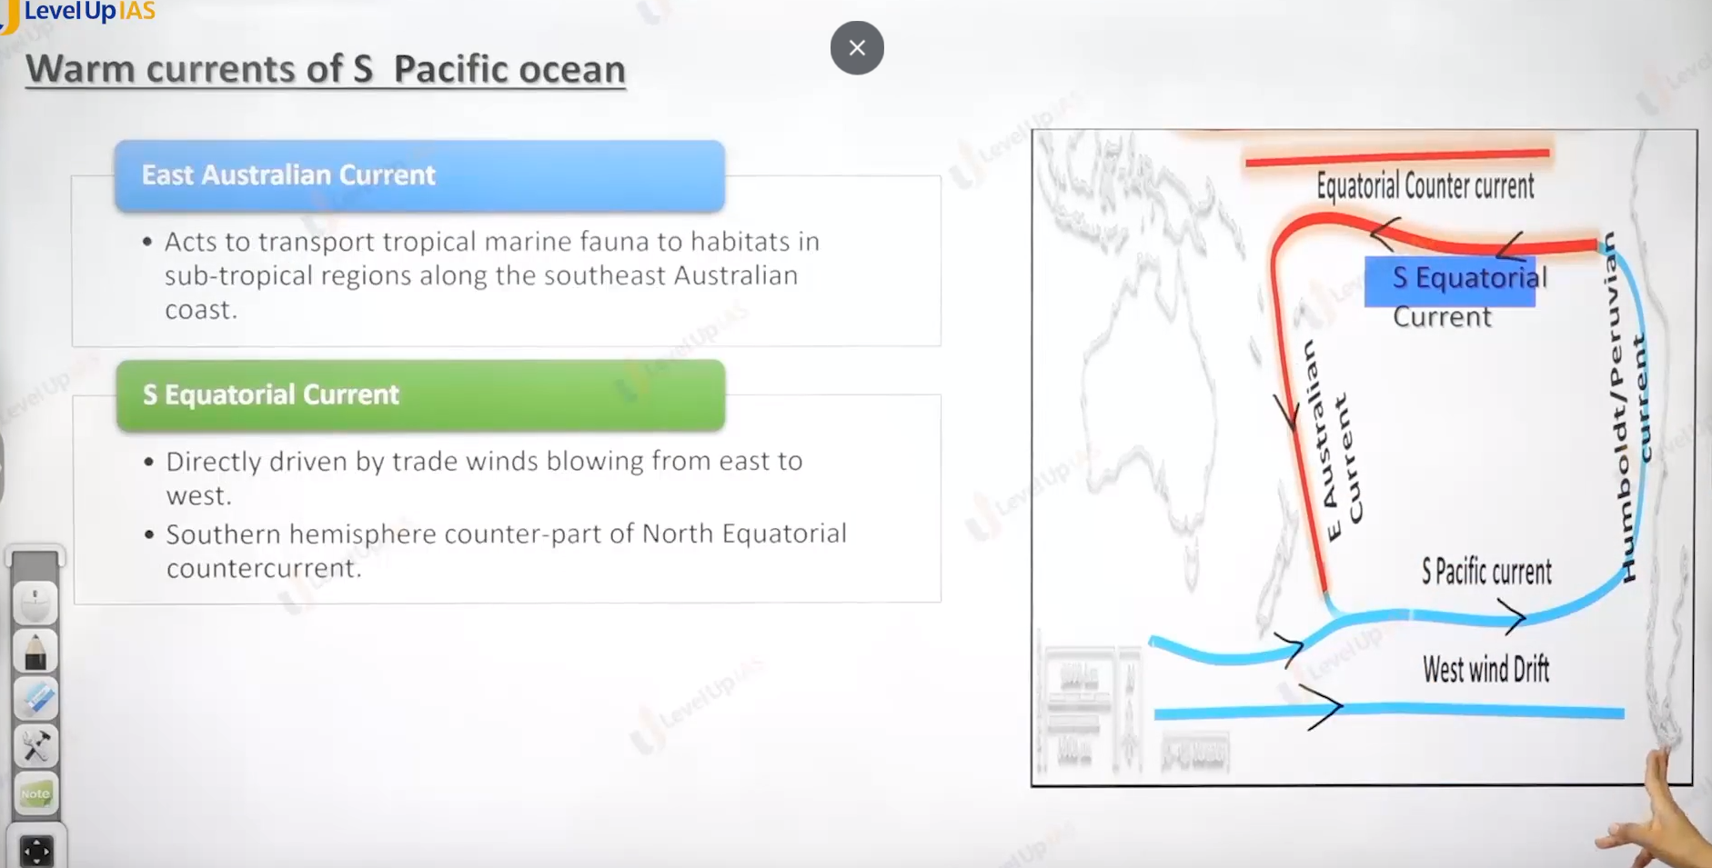

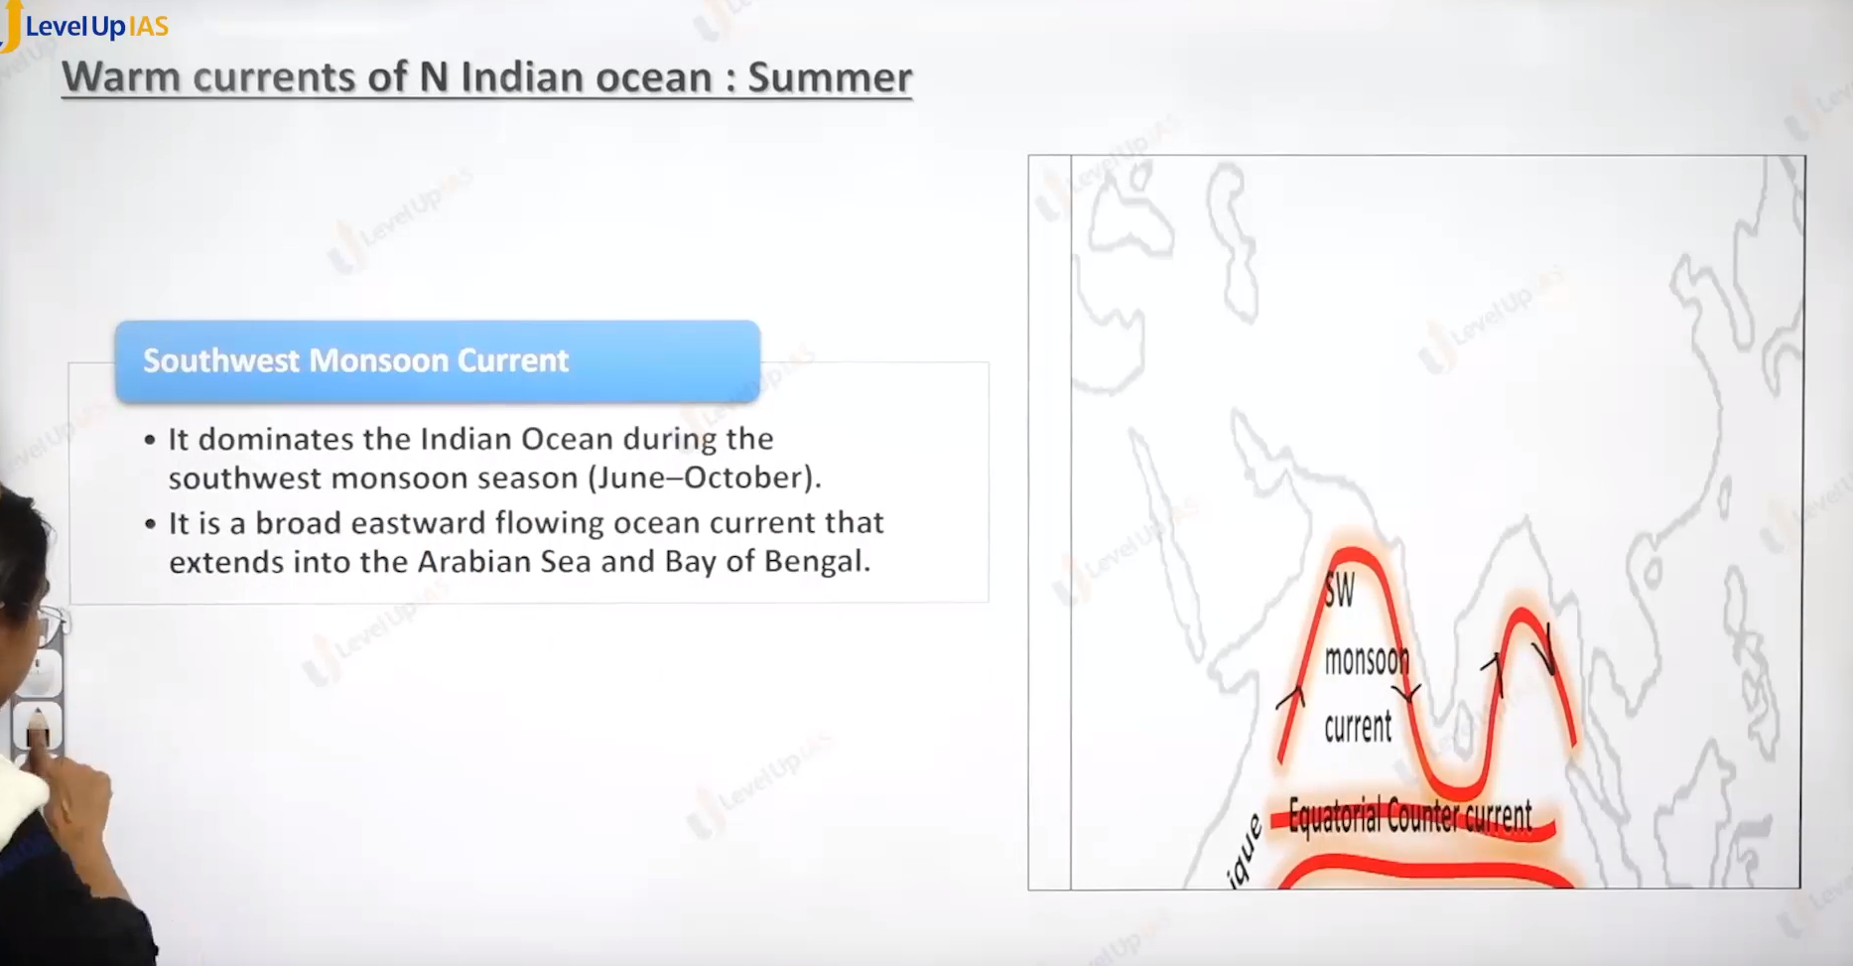

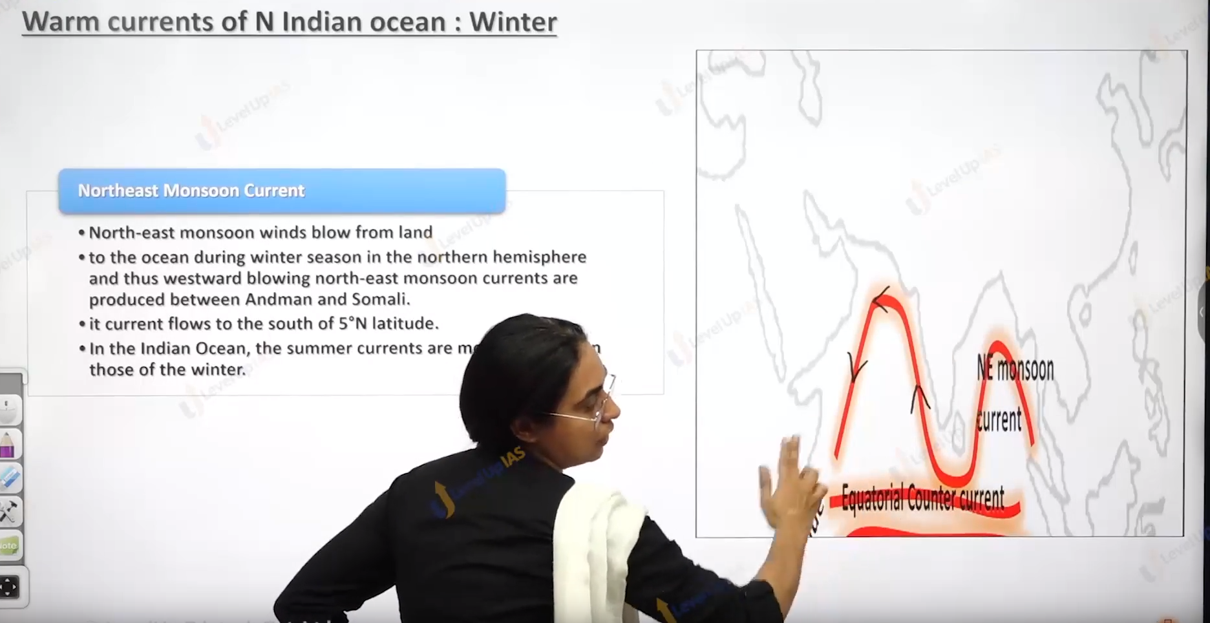

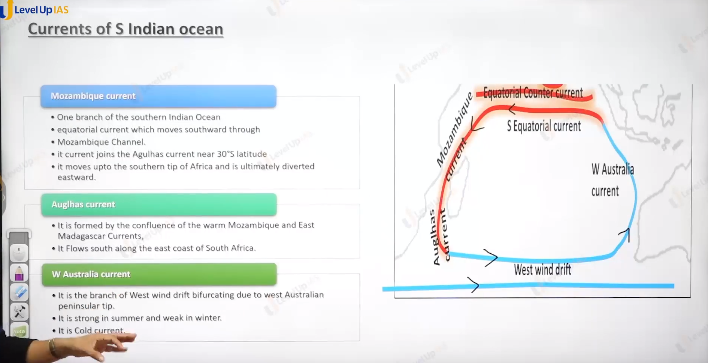

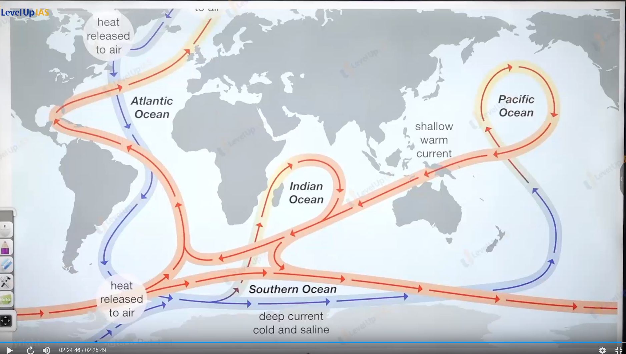

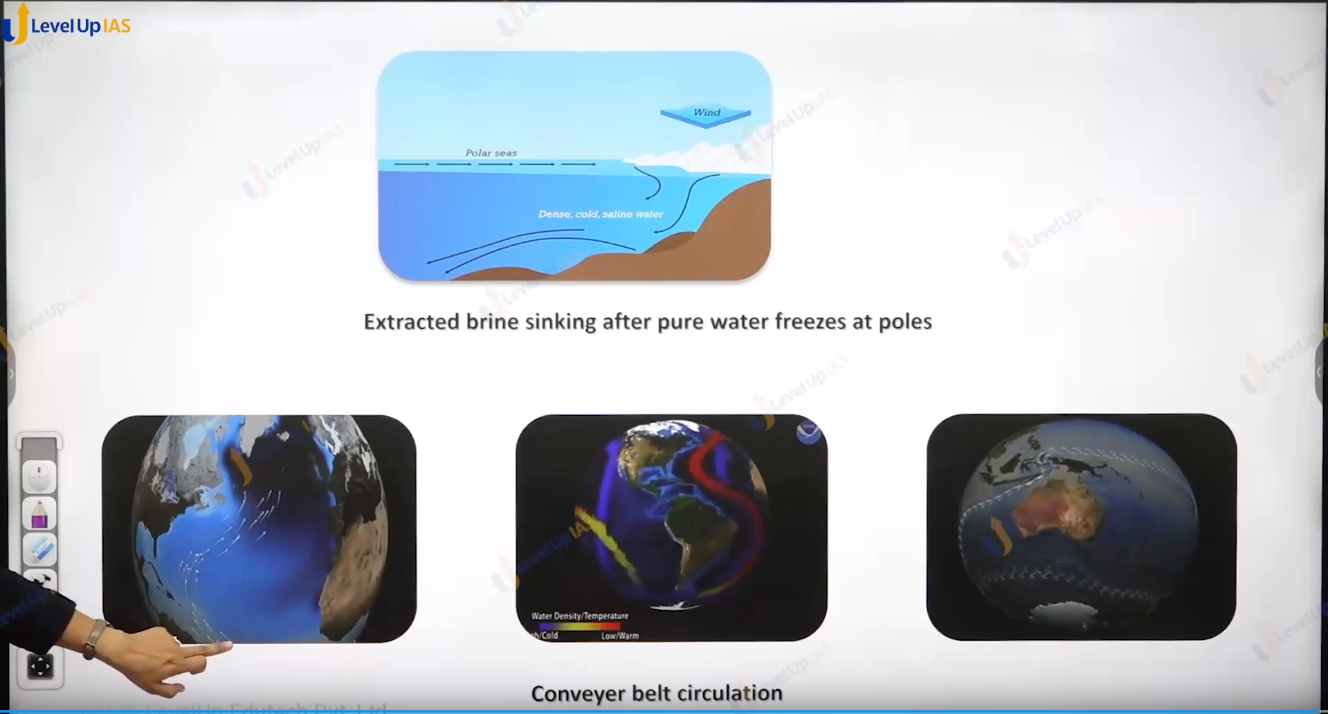

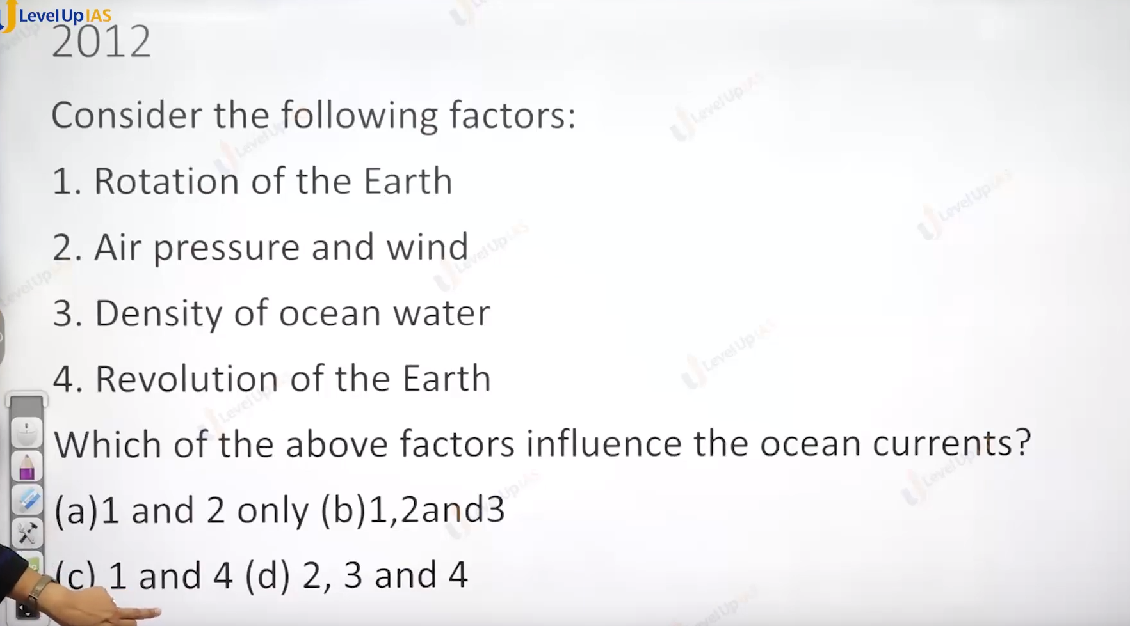

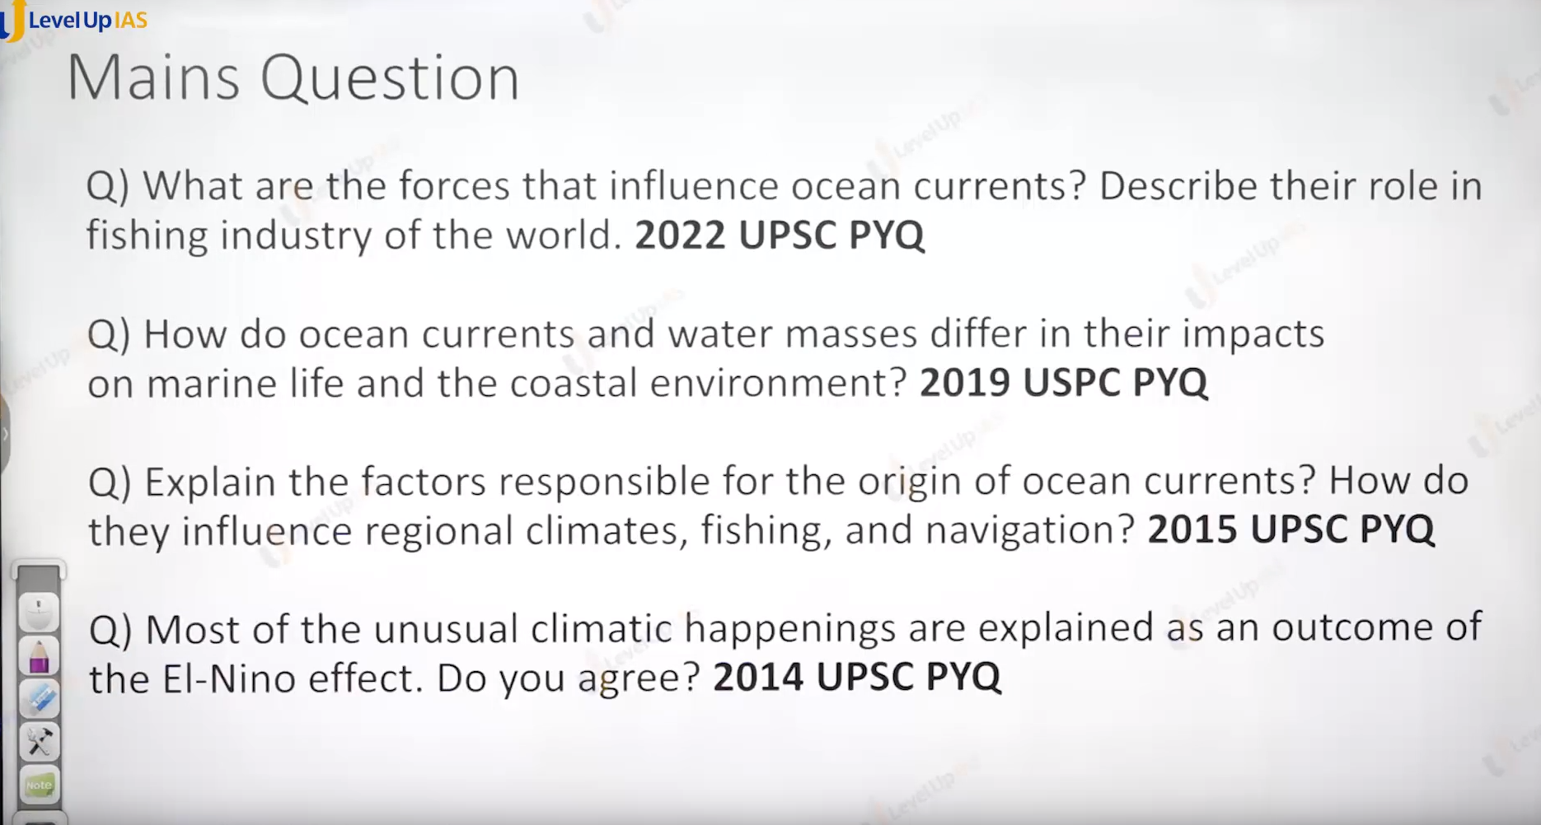

**(26) El Nino**

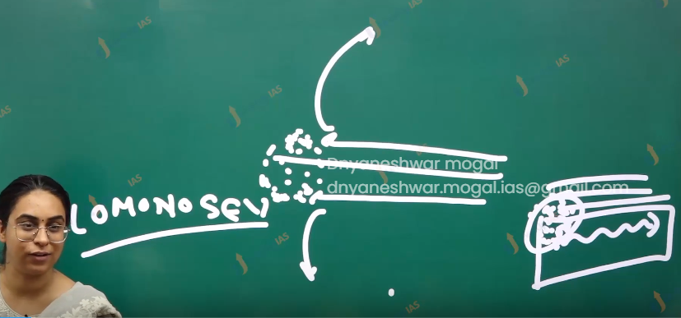

Formation of counter equatorial current:

1. At the equator due to piling up the water because of north and south equatorial current) a counter equatorial current close in the opposite direction that is west to east just below the surface, therefore counter equatorial current is sub-surface current.
2. It is a warm equatorial current. Ex. Lomonosov is counter equatorial current in the Atlantic ocean, Cromwell is CEC in the pacific ocean.,
3. TREEV is CEC of Indian ocean.

North Indian ocean current:

1. The relationship between ocean current and winds best seen in the Indian ocean
2. Due to reversal of winds, there is reversal in the current in the north Indian ocean. Northeast monsoon winds from the land drive waters from the way of Bengal and Arabian sea. In an anticlockwise manner.
3. Called as north east monsoon drift where as south west monsoon winds produce clockwise flow called as south west monsoon rift.

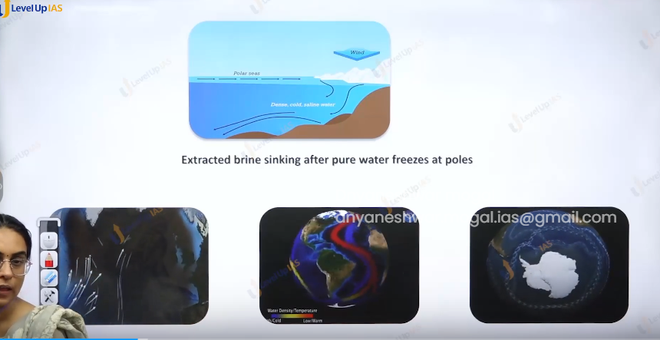

Vertical ocean current: (thermohaline current)

1. Most of the currents are perceptible on the surface, these are surface ocean current.
2. Surface ocean currents is primarily driven by the winds. The effect of winds can be most effective up to 1000m.
3. Deeper water beyond 1000m are not driven by winds but it is driven by temperature difference and salinity water and the density of water.
4. These deep currents are called as stenohaline current.
5. This is large scale oceanic circulation, and they cover 90% oceanic water circulation.
6. It begins near the polar region where ice form the leaving the water saltier and dancer leading the sinking of water.
7. This water moves slowly in the single belt / continuous belt across the different ocean and acts as medium to transfer the heat across globe.
8. Thermohaline circulations are nothing but the movement of water masses.
9. The water mass huge body of water with nearly same temperature salinity, comparable density.

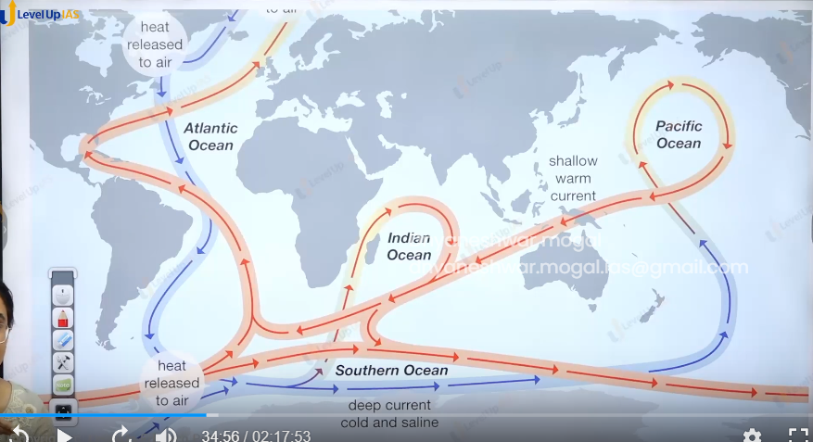

Significance of ocean current:

1. Cold ocean currents along the western coast in the sub-tropical region. Suppresses the precipitation increasing the aridity of desert.
2. Ex Namib desert and Benguela current, Atacama Desert and Peru current. Great Australian desert cold west Australian current. Mohave desert, cold California current. Sahara Desert and cannabis current.
3. Cold ocean current
4. Warm oceanic current along the east coast in the tropical and subtropical latitude can induce precipitation. The warm ocean along the temperate regions can create mild winters. And keeps the coast ice tree.
5. Ex Norwegian current keeping the port of Norway ice free.
6. Polar current can reduce temperature of region in the mid latitude.
7. Ex. Labrador current, east Greenland current.
8. Meeting upon the warm current and cold current can create optimum temperature current for the growth of planets leading to good fishing ground ex. Great bank of newfoundland near the labrador current and Gulf Stream in the north Atlantic ocean and Kuroshio (location north of Japan).
9. Meeting up warms and cold ocean current can leads to fog formation which can obstruct navigation.
10. Ocean currents also facilitate navigation.
11. Ocean currents help in global distrution of temperature and salinity.
12. Cold ocean currents due to upwelling can increase the nutrients facilitate / provide the good fishing ground.
13. Ex. Hambold along the peruchill region.

Importance of water mass:

1. It can help in the generation and maintenance of thermohaline circulation.
2. It can help in redistribution of oxygen salinity and temperature across the ocean
3. It can helps in generation of vertical circulation and facilitate redistribution of heat from the surface to depth and vice versa.

El Nino El Nina //// ENSO

(El Nino southern oscillation).

1. Enso is a phenomenon of reversing the ocean currents and reversing the water circulation that can also reverse the atmospheric circulation.
2. This is associated with alternate flood and drought conditions.
3. Thos Enso is best developed in the pacific ocean (southern ocean) but it has global impact therefore Enso is called as global ocean atmosphere telecommunication.

IN normal years

1. Trade winds are very strong.
2. Equatorial current of pacific are strong
3. It creates warm wester pacific pool in the western pacific therefore the difference between temperature and pressure conditions exists in the western and eastern pacific in the southern hemisphere there is raising air along the western pacific and sinking air along the eastern pacific. (along Peru coast) this is called as walker circulation
4. The consequences are warm wet conditions in Indonesia, north of western Australia and dry conditions along Peru coast. That facilitates the good upwelling and good fishing ground.

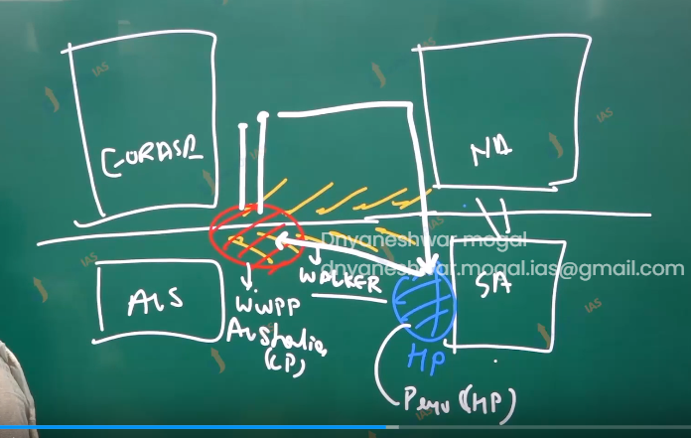

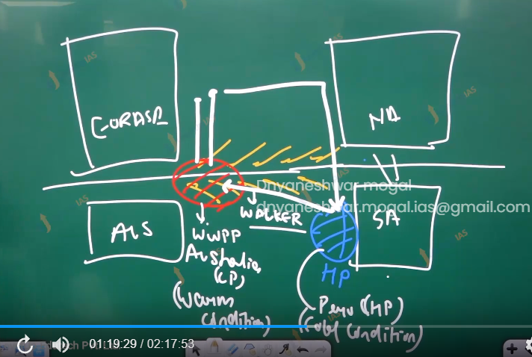

During the El Nino year.

1. For the reasons does not know trade winds of the pacific can slow s downs.
2. This weekend the equatorial current of pacific. Therefore, warm west pacific pools spread backwards and moves eastwards, therefore low pressure in Australia can weaken and may also be converted to high pressure, the high pressure at Peru can weaken or coveted to low pressure.
3. Therefore, walker cells can weaken or can get reversed.
4. This leads to drought and flood; it leads to drought and forest fire in Indonesia and Australia and it leads to flood in Peru
5. It impacts Peru economic because of lack of upwelling and lack of fish catch.

La Nina years

1. In some years, Tradewinds become unusually strong. Leading to very strong equatorial current, very strong warm wettest pacific pools, very strong Peru currents, very strong walker cells
2. (Strengthening of normal years.)
3. Consequences are Indonesia and Australia can have very strong rainfall and floods whereas Peru has very strong upwelling therefore there is very good fish catch. The market will glut. Because of over supply in the market prices crash.

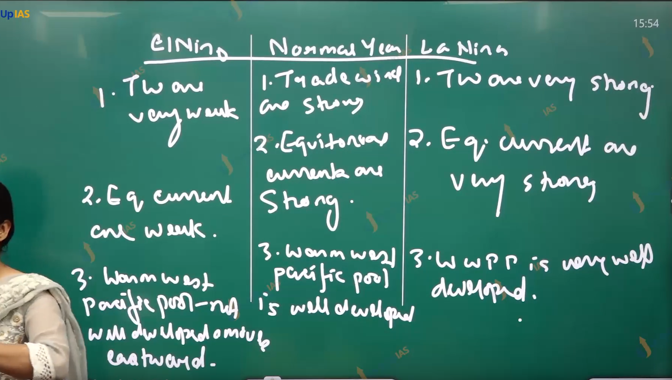

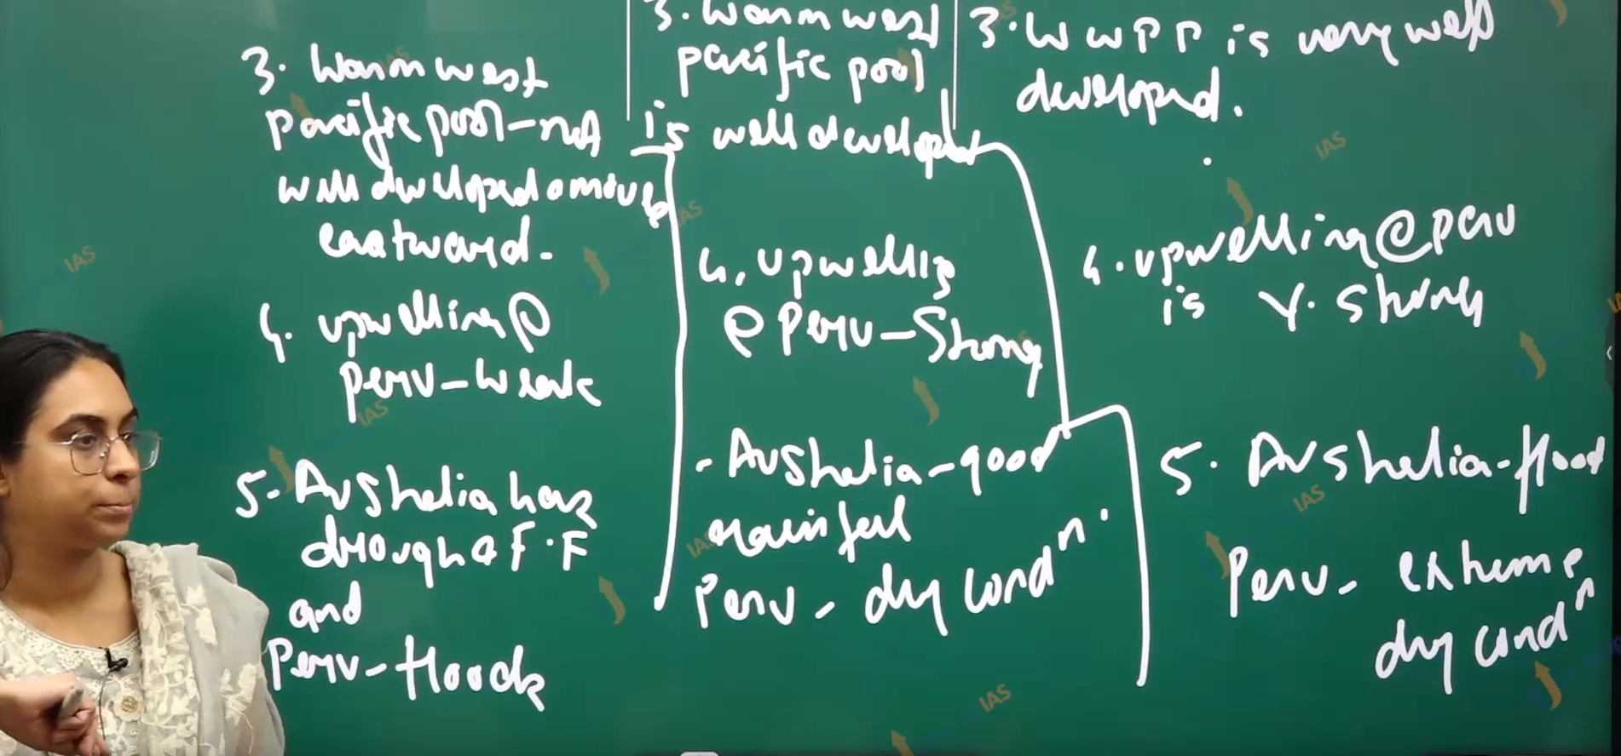

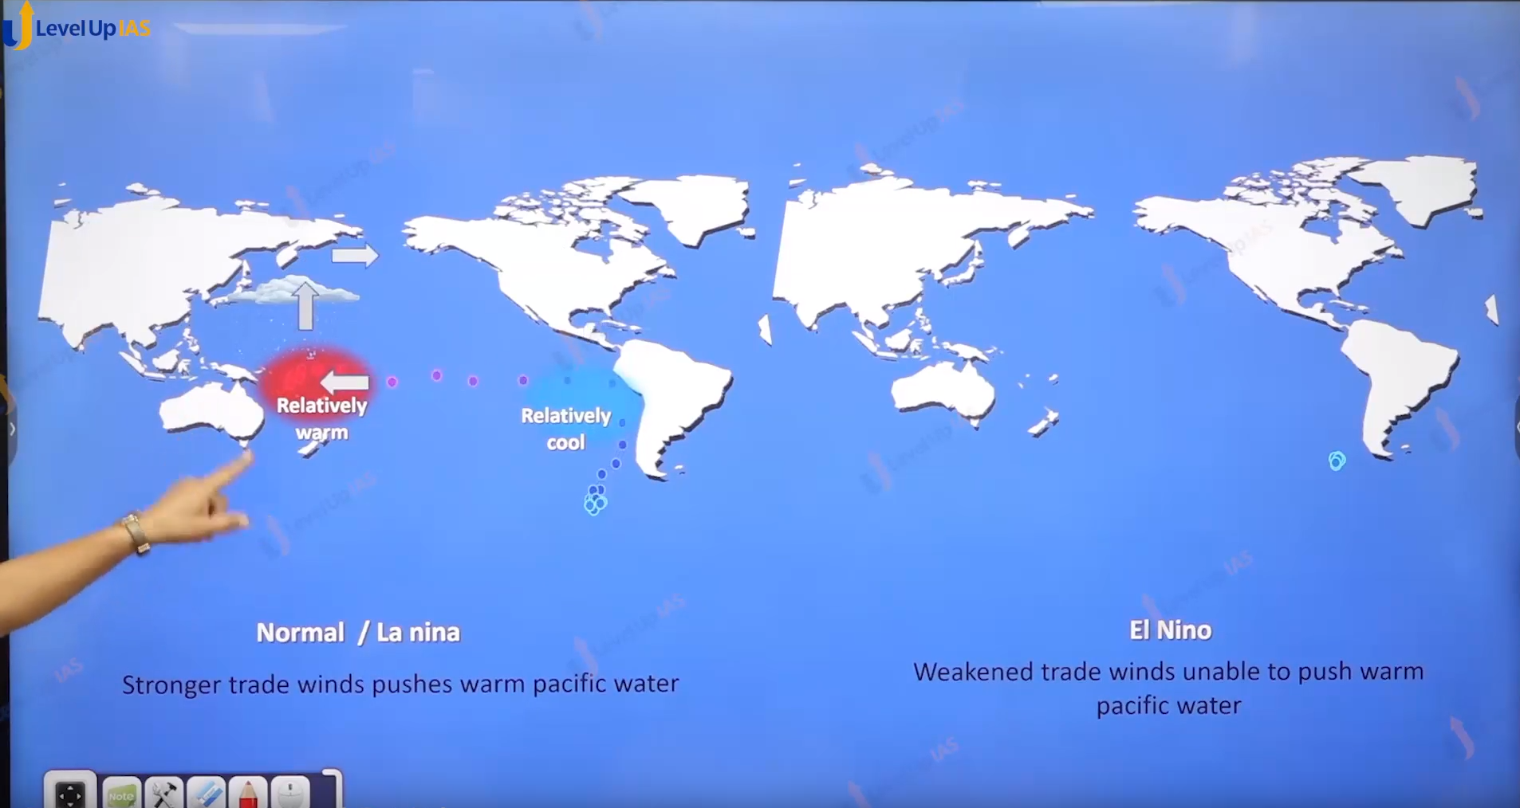

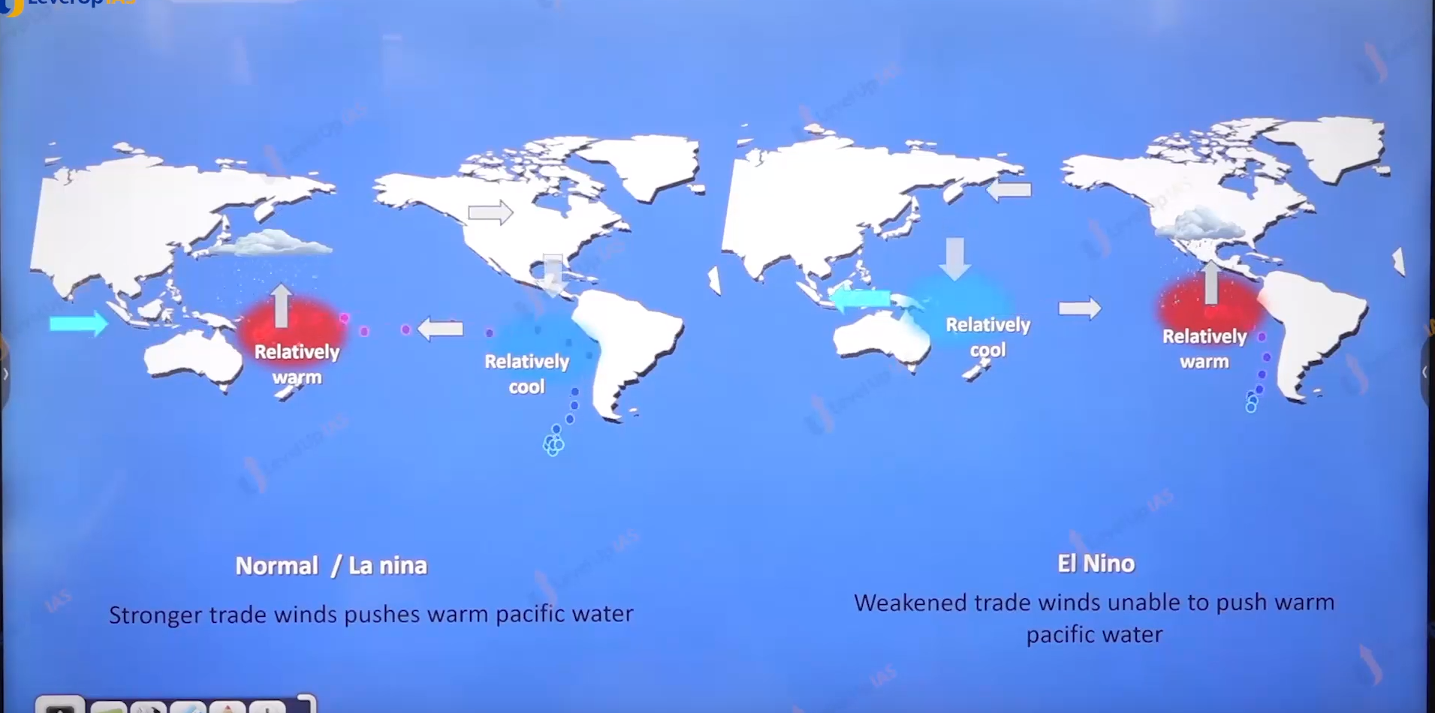

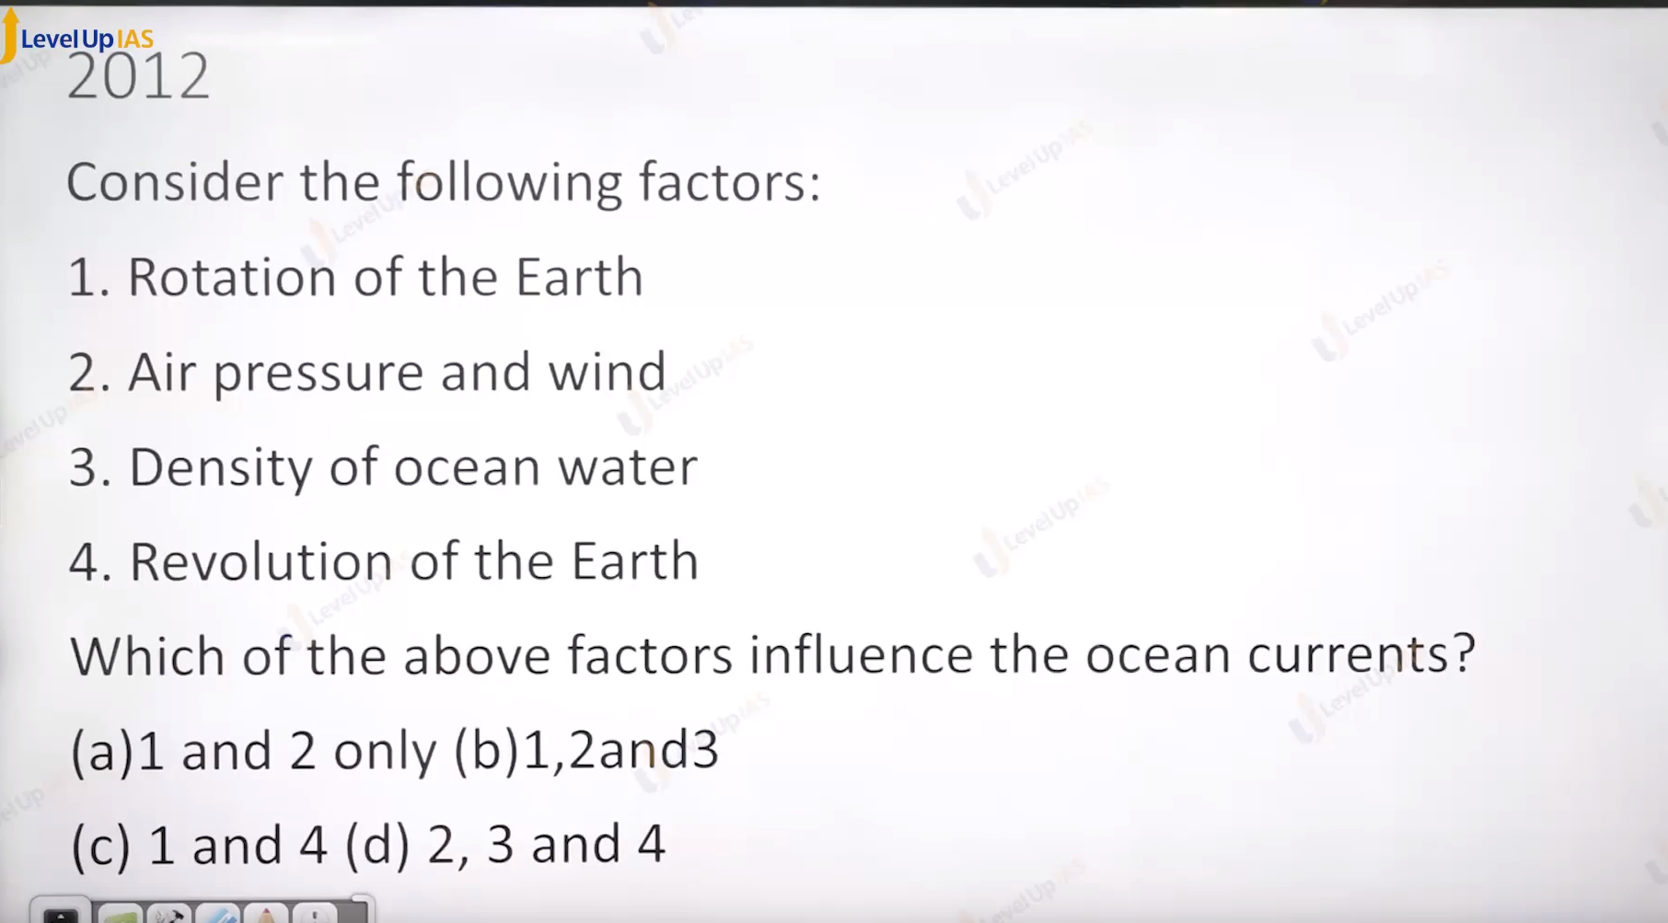

Answer B

Ocean is not stable water bodies. There are motions

1. Horizontal circulation motion due to trade winds.
2. Vertical circulation due to density, salinity, temperature.
3. wave
4. Tide (amount of water depends on the revolution.) gravitantional pull of sun and moon.
5. cyclone

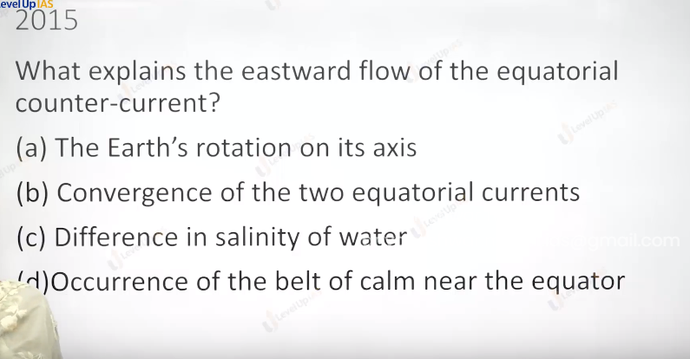

Ans b

Salinity at both points would be the same just water is displaced. Vertical currents are dependent on the difference in salinity. It will create the ocean current when there is enclosed sea.

Belts of calm near the equator can be created due to warm and cold ocean current. Which only affects the weather.

A is wrong because the direction of counter equatorial current is opposite to what it supposed to be. Earth rotates from west to east.

Current should flow from east to west. But we can see their direction is west to east.

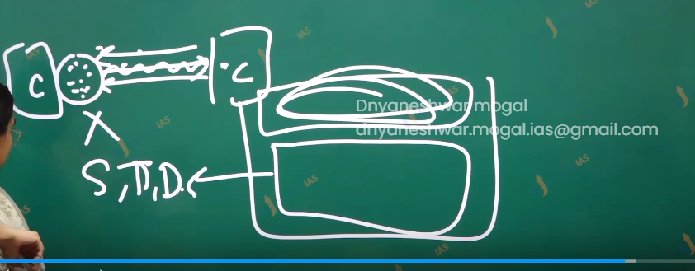

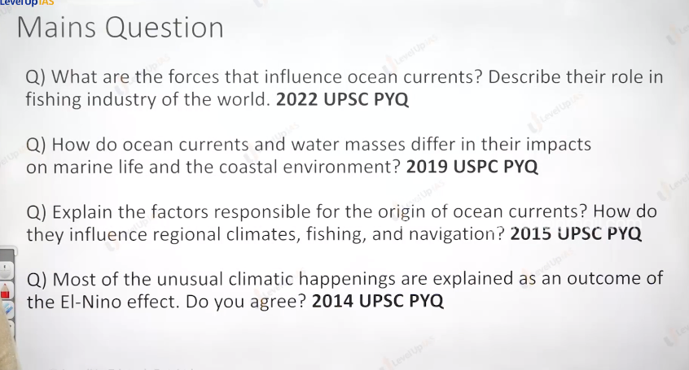

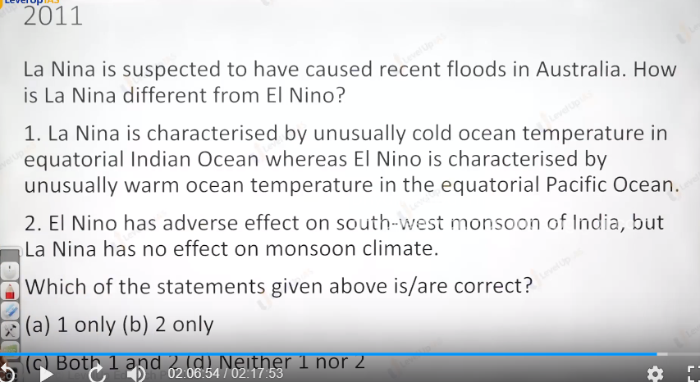

Ans is d

Cold ocean current +++ no rain

Warm ocean current rain.

In A oppositive are given that why this is wrong.

In the option second both El Nino and La Nina as effect on monsoon clement.

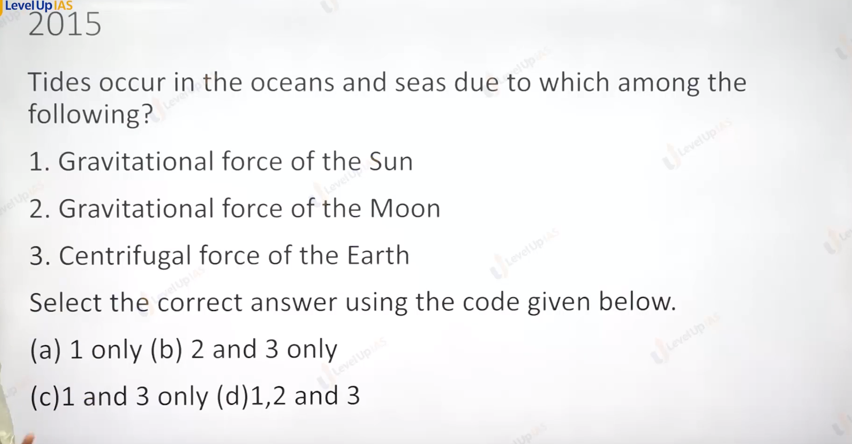 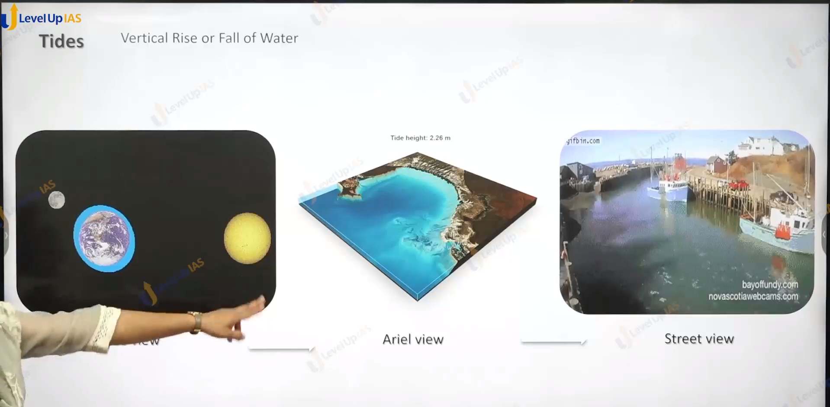

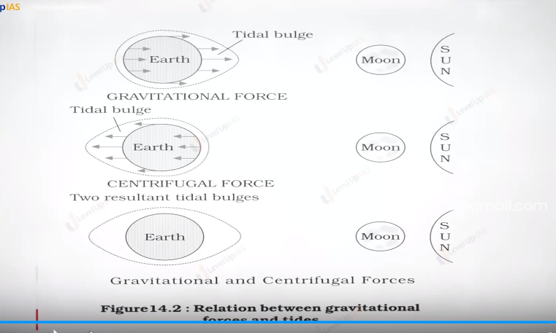

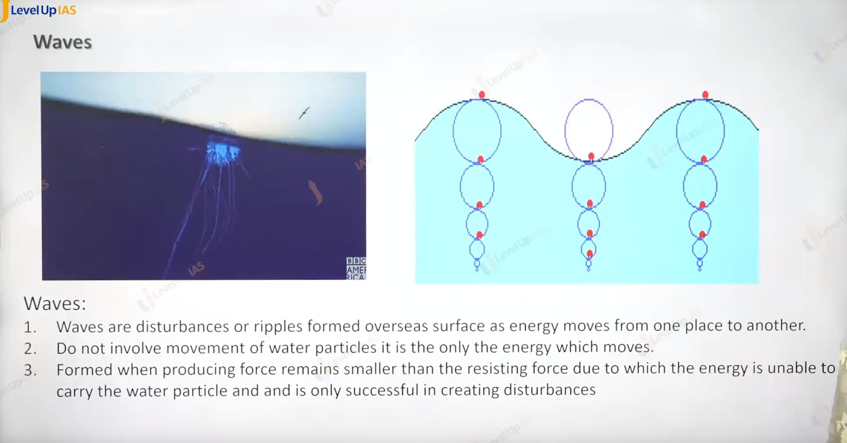

Ans d .

